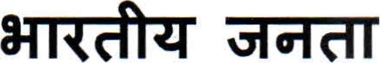
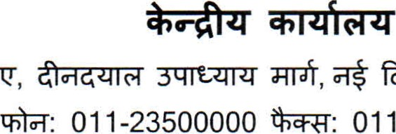
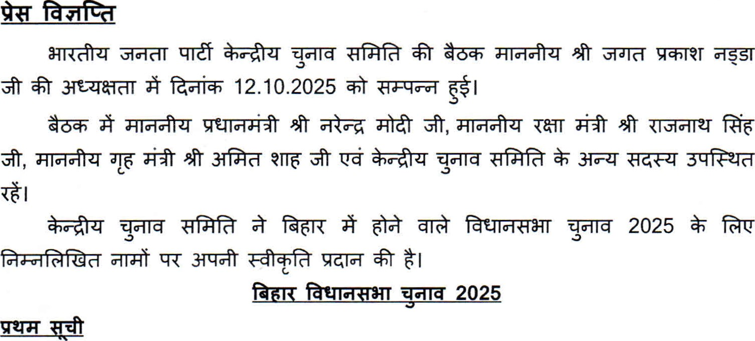
R-*r-110002 011-23500190
6v,
011-23500000
14.10.2025
 | 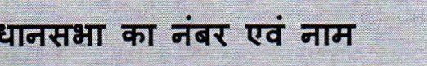 |  | 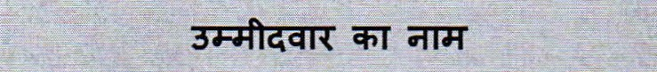
 | 8 | Bettiah | 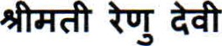  Smt. Renu Devi
2. | 10 | Raxaul | 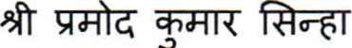  Shri Pramod Kumar Sinha
3. | 17 |  | 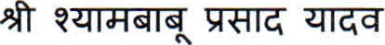  Shri Sh ambabu Prasad Yadav
4. | 18 | Madhuban | OTT 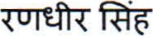  Shri Rana Randhir Sin h
5. | 19 | Motihari | 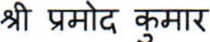  Shri Pramod Kumar
6. | 21 | Dhaka | 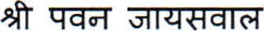  Shri Pawan Jaiswal
7. | 23 |  | 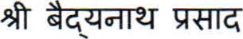  Shri Baid anath Prasad
8. | 24 | (3.GT)  Bathnaha SC | 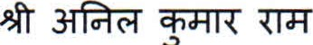  Shri Anil Kumar Ram
9. | 25 | Parihar | 'h•a0r 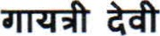  Smt. Ga atri Devi
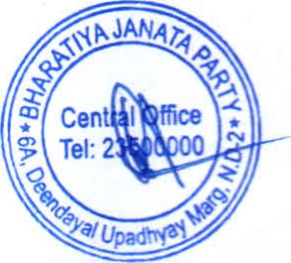
F. | 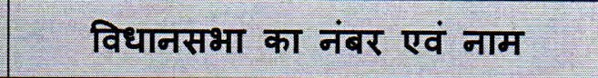 |  | 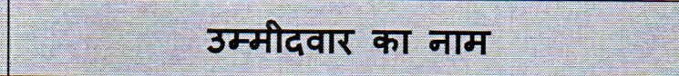
10. | 28 | Sitamarhi | 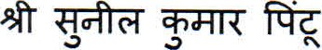  Shri Sunil Kumar Pintu
11. | 32 | Beni atti | 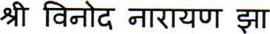  Shri Vinod Nara an Jha
12. | 33 | Kha•auli | 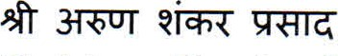  Shri Arun Shankar Prasad
13. | 35 | Bisfi | 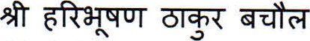  Shri Haribhushan Thakur Bachaul
14. | 37 | Ra•na ar SC | 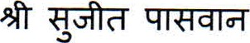  Shri Su•eet Paswan
15. | 38 | Jhan'har ur | #r8rqr  Shri Nitish Mishra
16. | 45 | Chhata ur | Shri Neera• Kumar Sin h Bablu
17. | 46 | 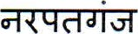  Nar at an | 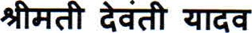  Smt. Devanti Yadav
18. | 48 | 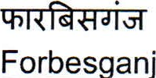 | Shri Vid a Sa ar Keshri
19. | 51 | Sikti | Shri Via Kumar Mandal
20. | 54 | 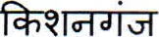  Kishan an | Smt. Sweet Sin h
21. | 59 | 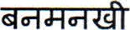(3T3r)  Banmankhi SC | 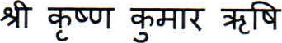  Shri Krishna Kumar Rishi
22. | 62 | Purnia | Shri Vi•a Kumar Khemka
23. | 63 | Katihar | 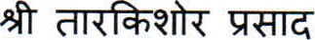  Shri Tarkishore Prasad
24. | 66 | Pran ur | 7qrr  Smt. Nisha Sin h
25. | 69 | (31Gff)  Korha SC | 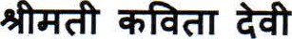  Smt. Kavita Devi
26. | 75 | Saharsa | 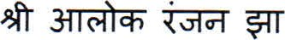  Shri Alok Ran•an Jha
27. | 79 | 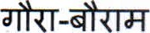  Gaura Bauram | 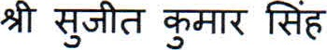  Shri Suit Kumar Sin h
28. | 83 | Darbhan a | 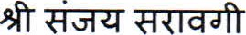  Shri San•a Sarao i
2
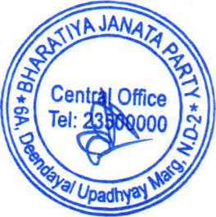

F. | 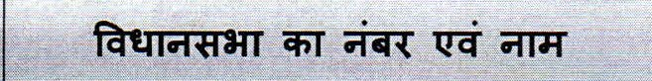 |  | 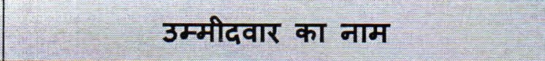
29. | 86 | Keoti | 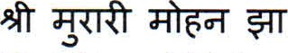  Shri Murari Mohan Jha
30. | 87 | Jale | 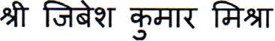  Shri Jibesh Kumar Mishra
31. | 89 | Aurai | 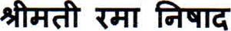  Smt. Rama Nishad
32. | 93 | 0  Kurhani | 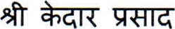 ag•caT  Shri Kedar Prasad Gu ta
33. | 96 | Barura | 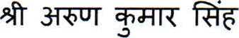  Shri Arun Kumar Sin h
34. | 98 | Saheb an' | 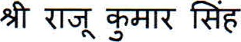  Shri Ra•u Kumar Sin h
35. | 99 | Baikunth ur | 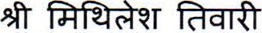  Shri Mithilesh Tiwari
36. | 105 | Siwan | 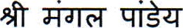  Shri Man al Pande
37. | 109 | Daraundha | 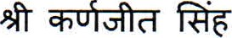  Shri Karn•eet Sin h
38. | 11 1 | 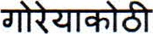  Gori akothi | 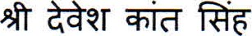  Shri Devesh Kant Sin h
39. | 1 16 | Tarai a | 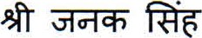  Shri Janak Sin h
40. | 120 | Amnour | 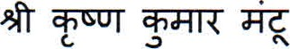  Shri Krishan Kumar Mantoo
41. | 123 | Hai ur | 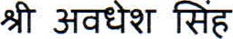  Shri Awadhesh Sin h
42. | 124 | Lal an• | Shri San•a Kumar Sin h
43. | 130 | (3T3r)  Pate ur SC | 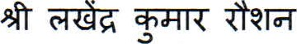  Shri Lakhendra Kumar Raushan
44. | 137 | 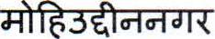  Mohiuddinna ar | 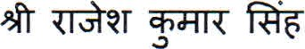  Shri Ra•esh Kumar Sin h
45. | 142 | Bachhwara | 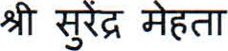  Shri Surendra Mehta
46. | 143 | Te hra | 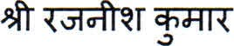  Shri Ra•nish Kumar
47. | 146 | Be usarai | 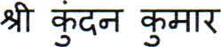  Shri Kundan Kumar
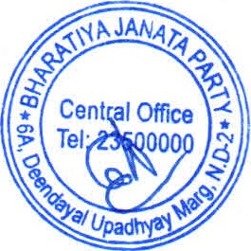

 | 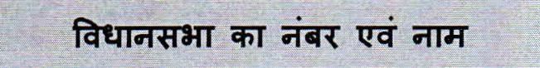 |  | 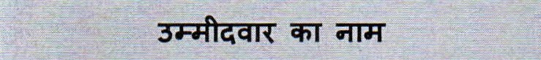
48. | 156 | Bha al ur | qi±zr  Shri Rohit Pande
49. | 161 | Banka | 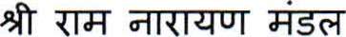  Shri Ram Nara an Mandal
50. | 162 | (3T33T)  Katoria ST | 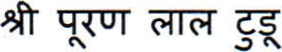  Shri Puran Lal Tudu
51. | 164 | Tara ur | 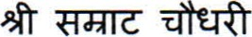  Shri Samrat Chaudha
52. | 165 | Mun er | 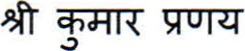  Shri Kumar Prana
53. | 168 | 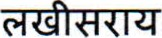  Lakhisarai | Shri Via Kumar Sinha
54. | 172 | 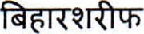  Biharsharif | 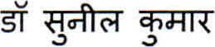  Dr. Sunil Kumar
55. | 181 | Di ha | 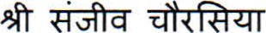  Shri San'iv Chaurasia
56. | 182 | Banki ur | 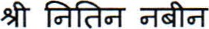  Shri Nitin Nabin
57. | 183 | Kumhrar | Shri San'a Gu ta
58. | 184 | 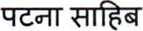  Patna Sahib | 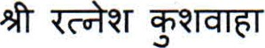  Shri Ratnesh Kushwaha
59. | 186 | Dana ur | 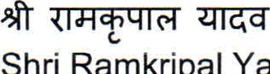  Shri  Ramkri  al  Yadav
60. | 191 | Bikram | 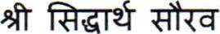  Shri Siddharth Saurav
61. | 193 | Barhara | 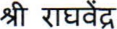 ga-rtr  Shri Ra hvendra Prata Sin h
62. | 194 | Arrah | "ZT$R"  Shri San•a Sin h "Ti er"
63. | 196 | Tarari | 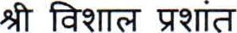  Shri Vishal Prashant
 | 214 | Arwal | 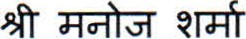  Shri Mano• Sharma
65. | 223 | 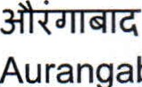  Auran  abad | 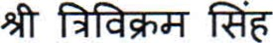  Shri Trivikram Sin h
66. | 225 | Gurua | 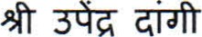  Shri U endra Dan i
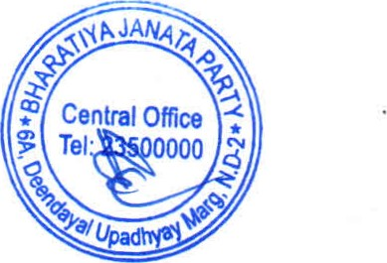

 | 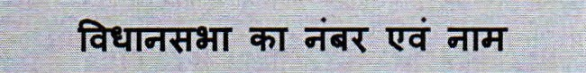 |  |  | 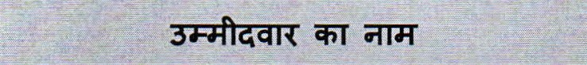
67. | 230 | Ga a Town |  | 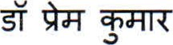  Dr. Prem Kumar
68. | 234 | Wazir an' |  | ft-ö  Shri Birendra Sin h
69. | 236 | Hisua |  | Shri Anil Sin h
70. | 239 | 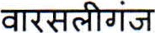  Warsali an |  | 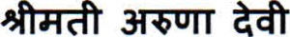  Smt. Aruna Devi
71. | 241 | Jamui |  | Sushri Shre asi Sin h
